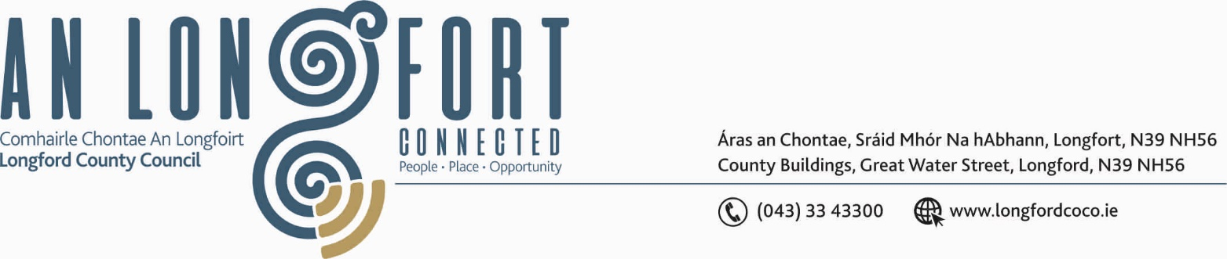

BALLYMAHON MUNICIPAL DISTRICT

Please note meeting will be held in Longford Rugby Club and via Microsoft Teams.

18th June 2021

To: Each Member of Ballymahon Municipal District.

A Chomhairleoir,

You are requested to attend the Annual Meeting of Ballymahon Municipal District to be held in Longford Rugby Club, Demesne, Longford on Thursday, 24th June 2021 at 4pm to transact business, as set out on the Agenda hereunder.

Mise le meas,

Ann Marie Mc Keon
______________
Ann Marie Mc Keon,
Meetings Administrator.

C L A R

1. Election of Cathaoirleach.

2. Election of Leas Cathaoirleach.

3. Fix date and time of Ballymahon Municipal District meetings.



